**Practical: 16 Write a c++ program :**

**a) to illustrate multilevel inheritance.**

#include<iostream>

using namespace std;

class student

{

protected : int rollno;

public :

void get_num();

void put_num();

};

void student::get_num()

{

cout<<"\nEnter the roll number:\t";

cin>>rollno;

}

void student::put_num()

{

cout<<"Rollnumber: "<<rollno;

}

class test:public student

{

protected : float sub1,sub2;

public:

void get_marks()

{

cout<<"\nEnter the sub1 marks: ";

cin>>sub1;

cout<<"\nEnter the sub2 marks: ";

cin>>sub2;

}

void put_marks()

{

cout<<"\nSub1="<<sub1;

cout<<"\nSub2="<<sub2;

}

};

class result : public test

{

float total;

public:

void display()

{

total=sub1+sub2;

put_num();

put_marks();

cout<<"\nTotal= "<<total;

}

};

int main()

{

result r;

r.get_num();

r.get_marks();

r.display();

return 0;

}

**Output 16**

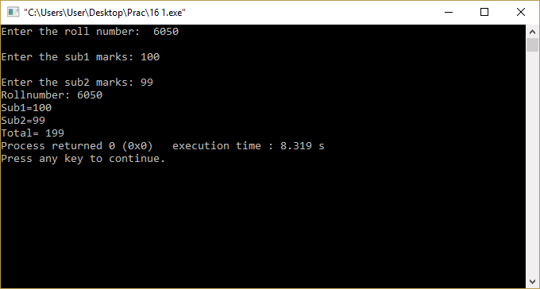

**b) to illustrate multiple inheritance.**

#include<iostream>

using namespace std;

class m

{

protected : int m;

public:

void getm()

{

cout<<"\nEnter the value for m : ";

cin>>m;

}

};

class n

{

protected : int n;

public:

void getn()

{

cout<<"\nEnter the value for n : ";

cin>>n;

}

};

class p : public m , public n

{

public:

void display()

{

cout<<"\nM="<<m;

cout<<"\nN="<<n;

cout<<"\nM*N="<<m*n;

}

};

int main()

{

p p1;

p1.getm();

p1.getn();

p1.display();

return 0;

}

**Output 16**

